Name: Gustavo Hammerschmidt.

Section ML Web Server Description:

This server returns a label to a submitted image. More specifically, the user sends the name of the image within the application(the reason for this approach was to ease the application development complexity, though it would not happen in a real scenario). The model used was a Keras CNN model, the same model that it was presented on a ipynb notebook posted on the class website. The dataset used was provided by a google api and its name is cats_and_dogs_filtered.

Testing the Web Server and Clients:

To test the server, first the user should run the server.sh file with ‘./’ on Linux, then he can either run get.sh or post.sh. All the files and images shall be under the same folder. The path to the files may be altered, if that is the case, then the user must change the paths on the files as well

Screen Captures of Test Run

Screenshot of “./server.sh” command run:

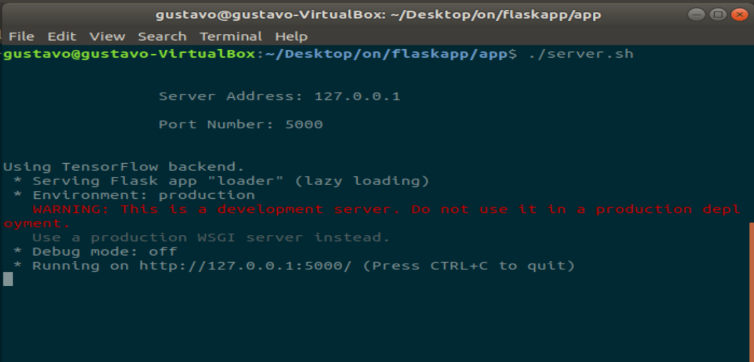

Screenshot of “./get.sh” command run:

Screenshot of “./post.sh” command run:

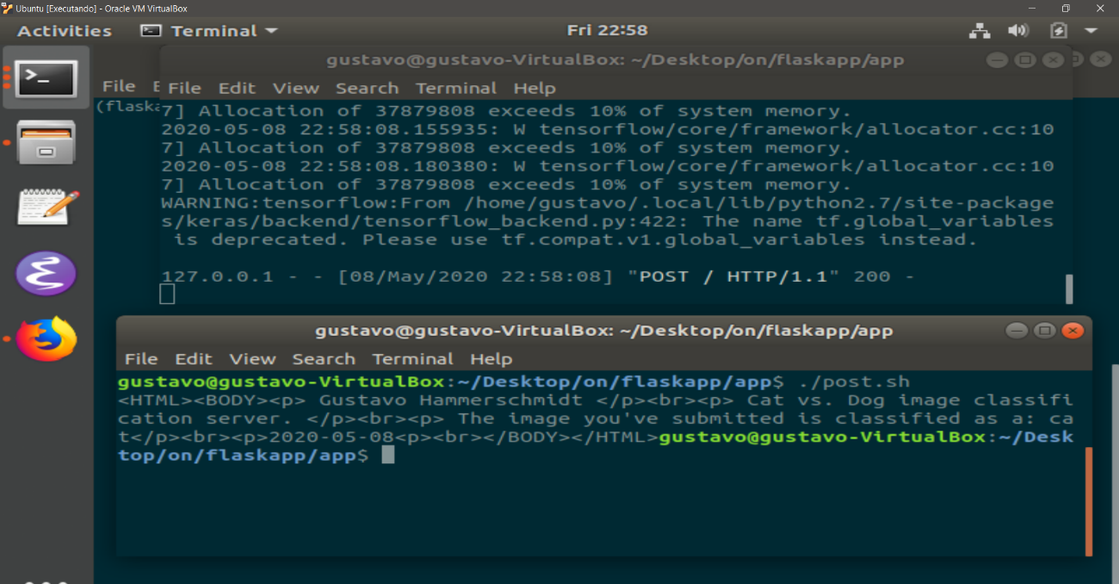

Ps.: I will put all files that I have used on sub directories to be better organized, but at execution all files must be on the same folder, therefore, I will also post a folder with all files.